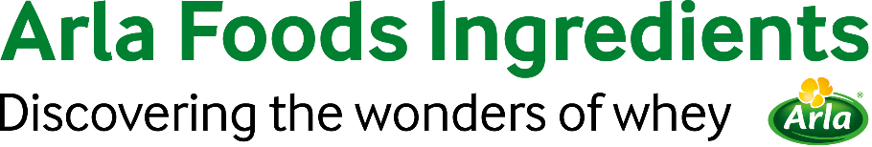

21st March 2023

PRESS RELEASE

Peptigen® IF-3080 approved by EU for use in infant formula

Peptigen® IF-3080, one of Arla Foods Ingredients’ protein hydrolysates for infant formula, has received final EU approval.

In February 2022, the EU introduced new regulations requiring evaluation of the safety and suitability of all protein hydrolysates used in formulas.

Shortly afterwards, the European Food Safety Agency (EFSA) published an opinion that Peptigen® IF-3080 was safe and suitable for use in formulas and follow-on formulas in the EU. It was one of only a few milk protein hydrolysates to achieve this status.

Now the product has been included in the Commission Delegated Regulation (EU) 2016/7 –
the final step necessary for it to be used in infant and follow-on formulas sold across the EU.

Anders Steen Jørgensen, Head of Arla Foods Ingredients’ Paediatric Business Unit, said: “It’s great news that Peptigen® IF-3080 has completed its journey to market in the EU. Safety and quality are of course paramount in infant nutrition, and this decision reflects our absolute commitment to the highest possible standards. We believe it will benefit manufacturers developing innovative products, as well as increasing the choice of high-quality formula available to parents.”

For more information contact:
Steve Harman, Ingredient Communications
Tel: +44 (0)7538 118079 | Email: Steve@ingredientcommunications.com

About Arla Foods Ingredients
Arla Foods Ingredients is a global leader in value-added whey solutions. We discover and deliver ingredients derived from whey, supporting the food industry with the development and efficient processing of more natural, functional and nutritious foods. We serve global markets within early life nutrition, medical nutrition, sports nutrition, health foods and other foods and beverage products.

Five reasons to choose us:
- We have R&D in our DNA
- We offer superior quality
- We are your trusted business partner
- We support sustainability
- We ensure security of supply

Arla Foods Ingredients is a 100% owned subsidiary of Arla Foods. Our head office is in Denmark.

LinkedIn
http://www.linkedin.com/company/arla-foods-ingredients

LinkedIn (Latin America)
https://www.linkedin.com/showcase/arla-foods-ingredients-latin-america/

LinkedIn (China)
https://www.linkedin.com/showcase/arla-foods-ingredients-china/

